BUILDING A RETAIL SALES DATA AGENT ON DATABRICKS
SUBMISSION

Name: Matsobane Mongau
Student no: 2805001616
Email: mongaumatsobane@gmail.com
Date: 24 May 2026

Contents
Introduction & Objectives 3
Dataset Descriptions 3
1. Upload: 4
2. Review of the Dataset 4
3. Prepare the table 6
4. Create the Data Agent 7
5. Own Instructions 8
6. Test with 10 Questions 9
7. Validate the Answers 14

Introduction & Objectives
We have been instructed to build a data agent using Databricks. We were given a data set CSV file containing data that was uploaded on Databricks to create the table retail sales data containing 1000 rows or transactions.
The purpose of the agent is to allow staff members to ask questions using straight language about sales performance and receive accurate answers.
The objective was to build an end-to-end data agent: upload the data, prepare the table, write original agent instructions, test the agent with real business questions, validate its answers, and document the entire process.

Dataset Descriptions
The dataset covers three product categories: Electronics, Clothing, and Beauty. It includes customer information such as gender and age, making it possible to analyse both product performance and customer behaviour patterns.
The dataset used in this project is the retail_sales_data table stored in Databricks (workspace.default.retail_sales_data). It contains 1,000 rows of retail sales transactions from January 2023 to January 2024.
Column Name | Data Type | Description
transaction_id | Integer | ID for each sale, numbered 1 to 1000
date | Date | Date the sale occurred in YYYY-MM-DD format
customer_id | String | Customer identifier
gender | String | Gender of the customer: Male or Female only
age | Integer | Age of the customer in years, between 18 and 64
product_category | String | Type of product: Electronics, Clothing or Beauty
quantity | Integer | Number of units purchased in the transaction
price_per_unit | Integer | Price of a single unit in dollars
total_amount | Integer | Total value of the transaction

Upload:
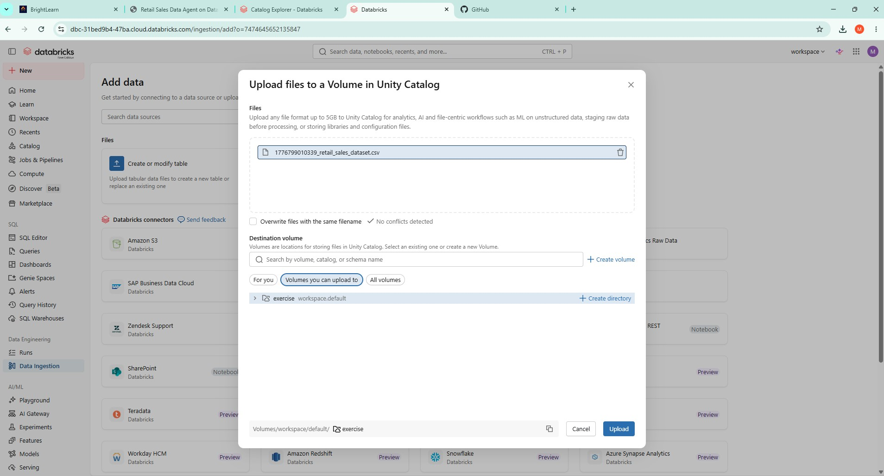
Upload 1 Failed – only uploaded 50 rows. Opted for option 2 for upload which uploaded all rows. See screenshot.

Review of the Dataset

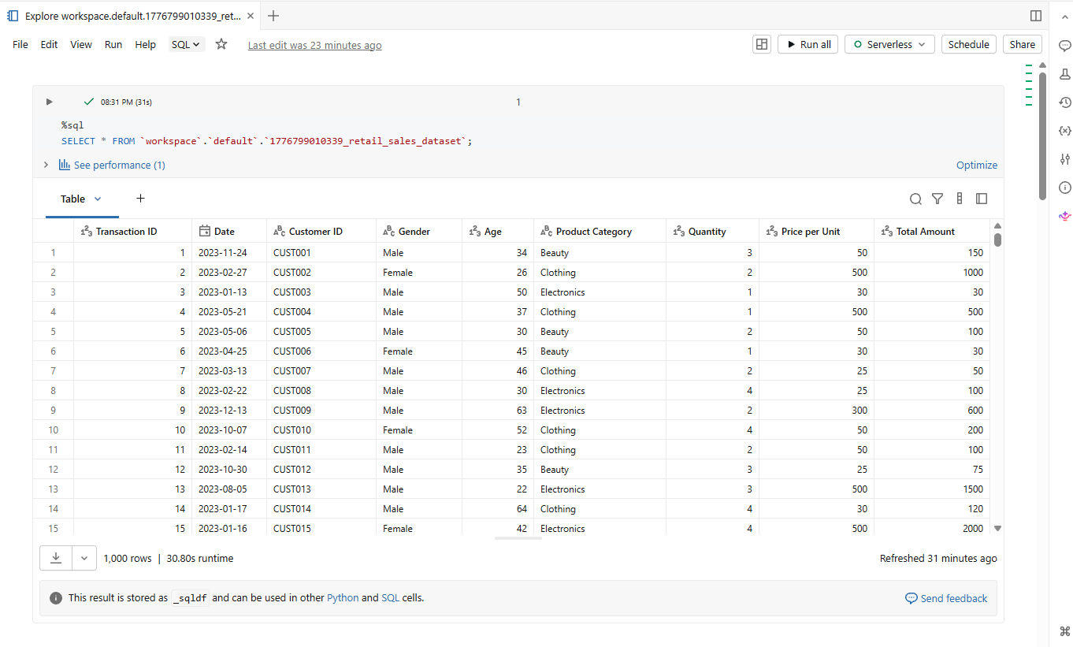

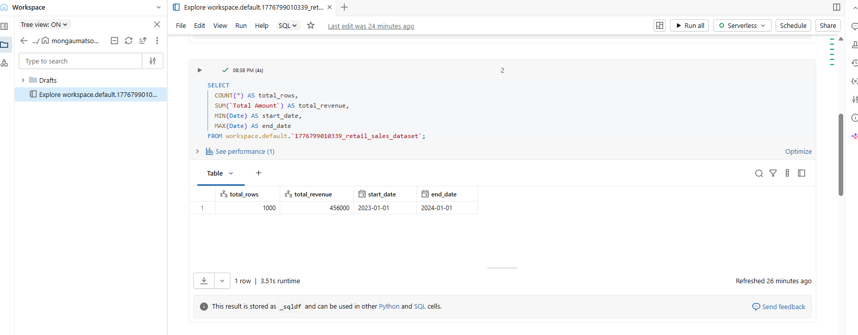

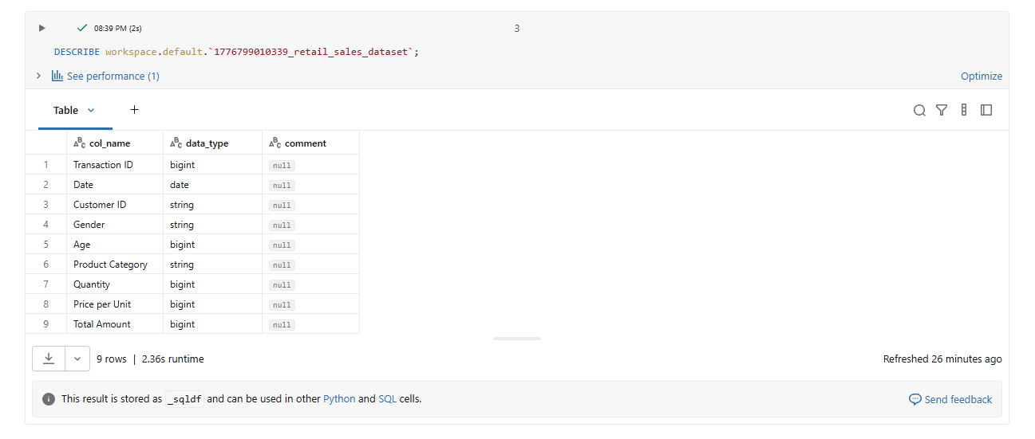

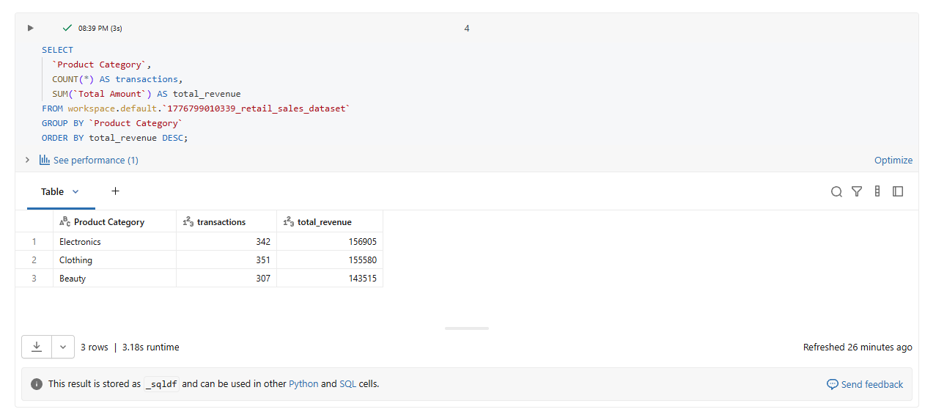

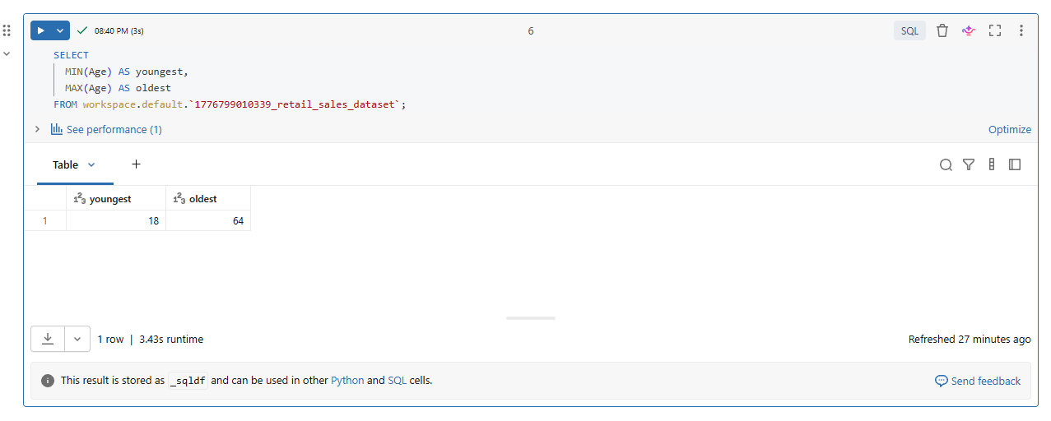

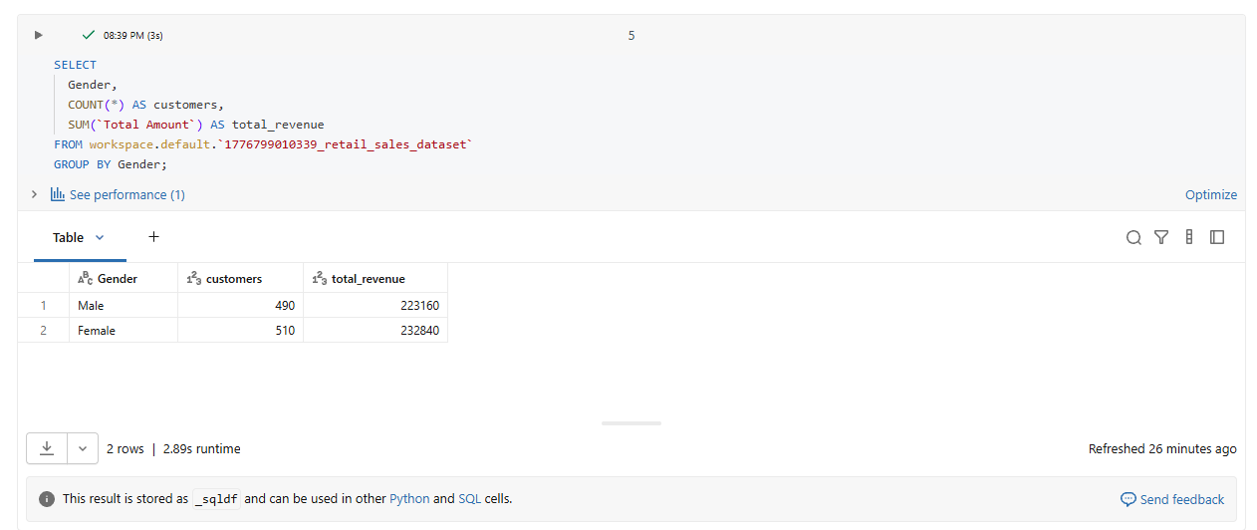

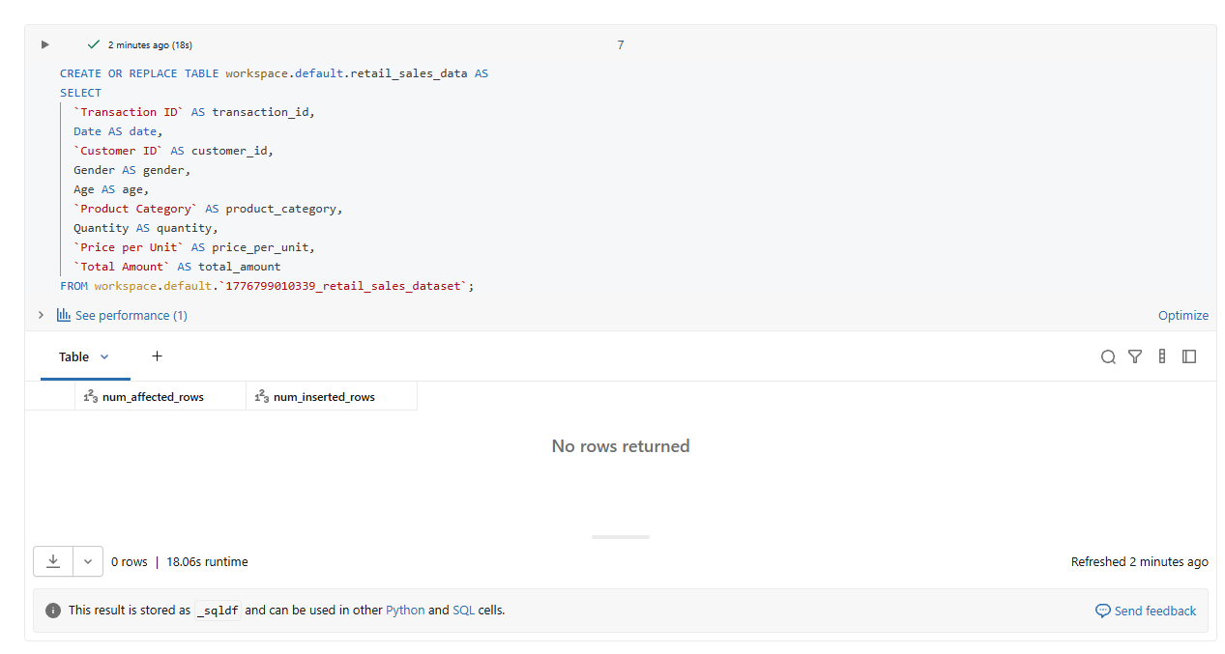
Prepare the table

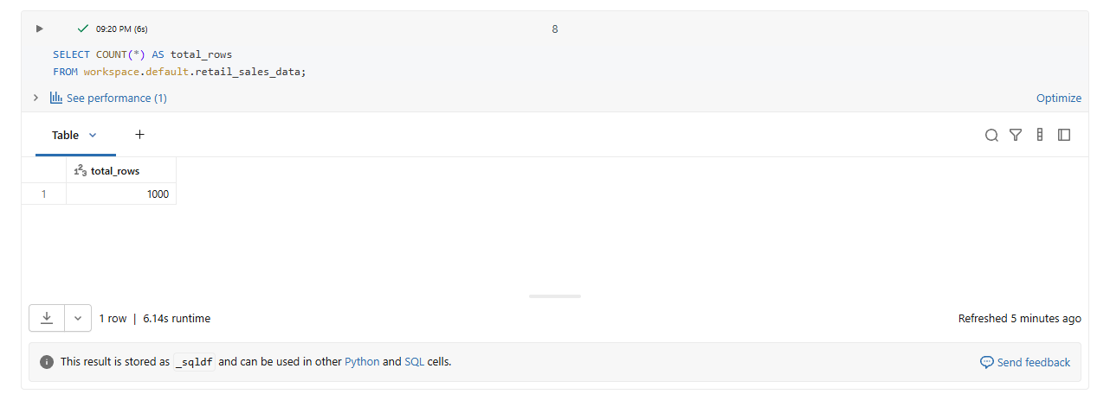

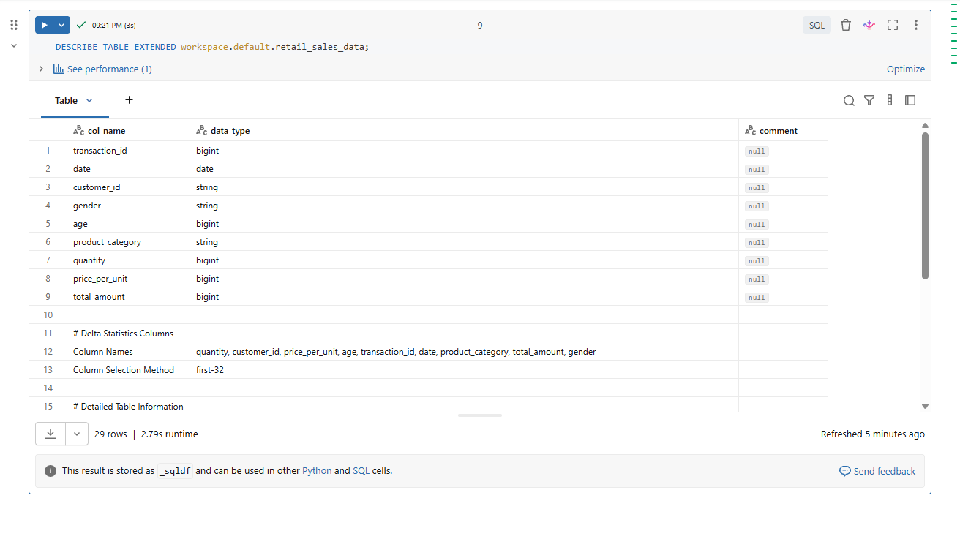

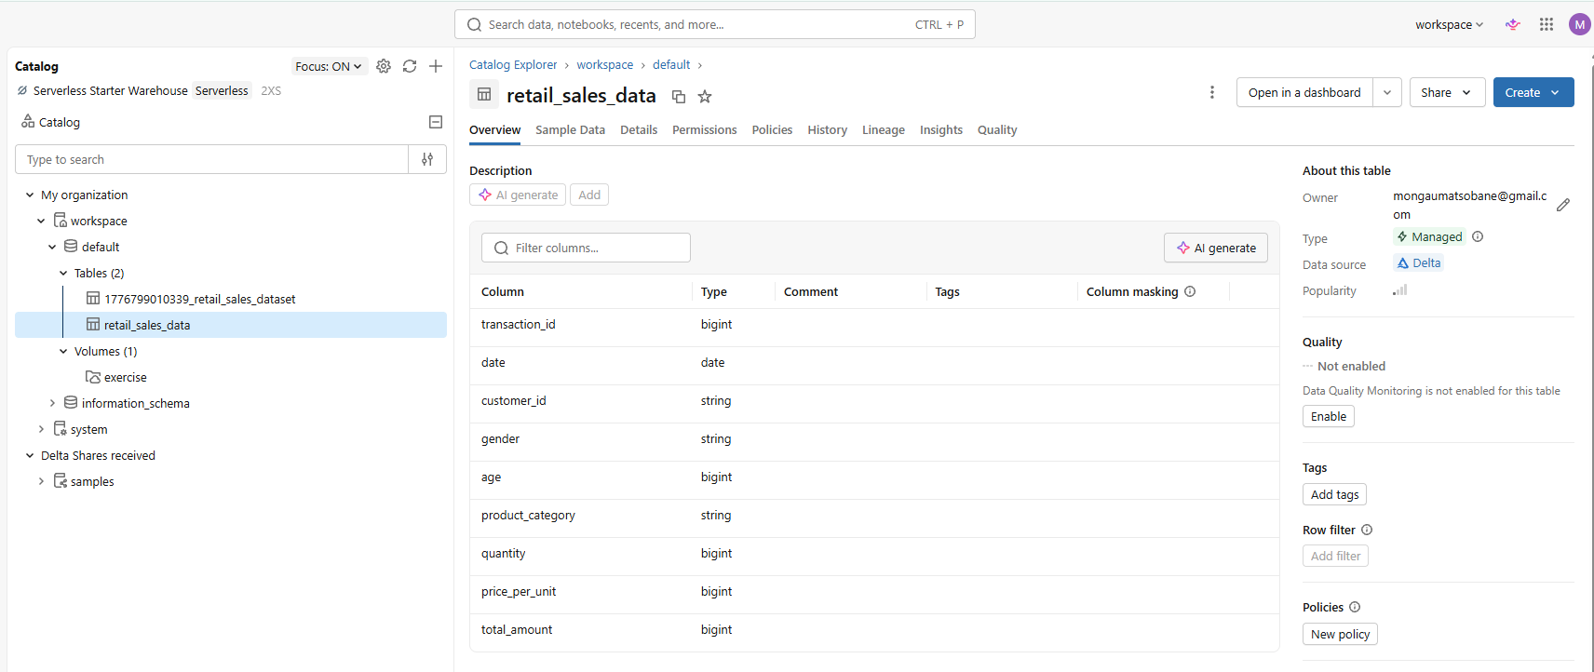

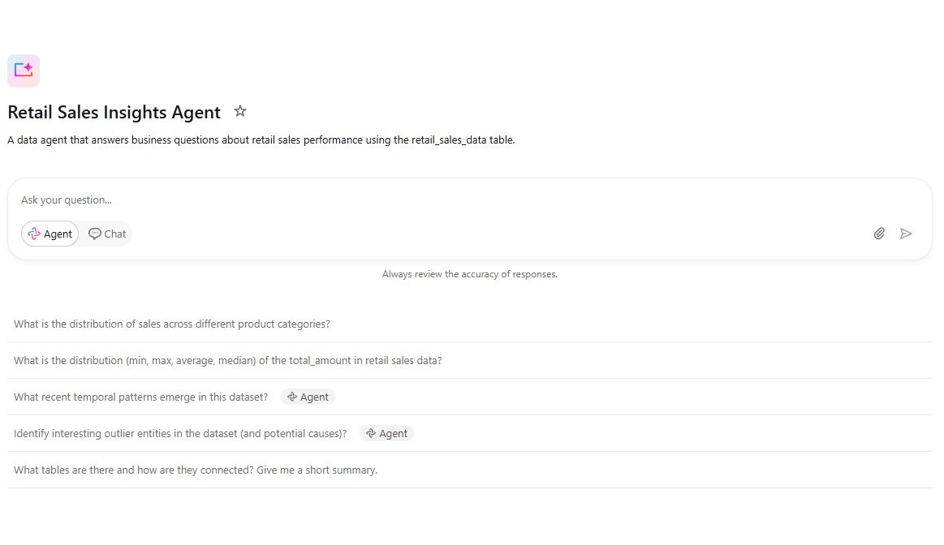
Create the Data Agent

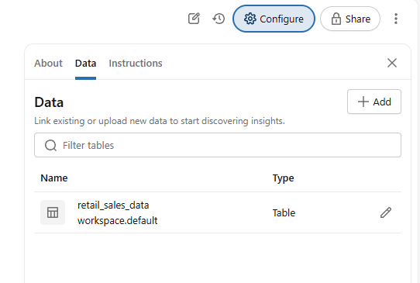
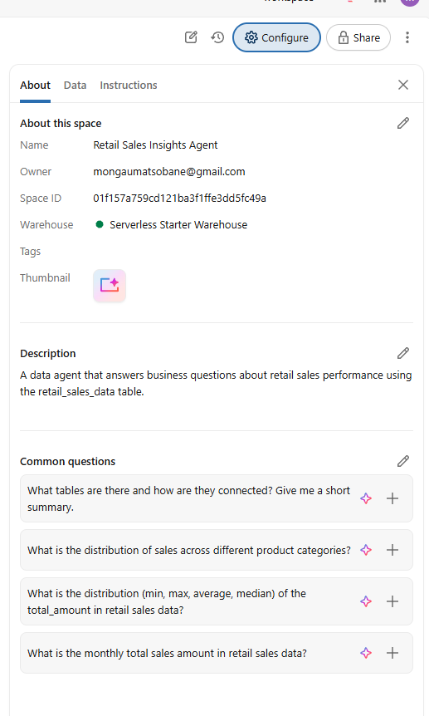

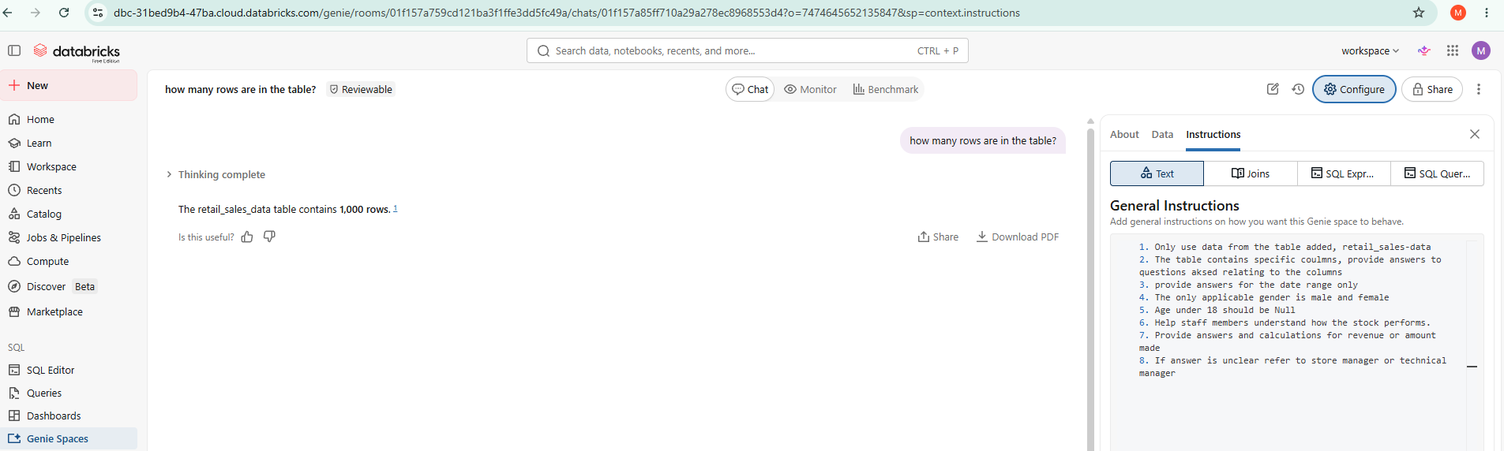
Own Instructions

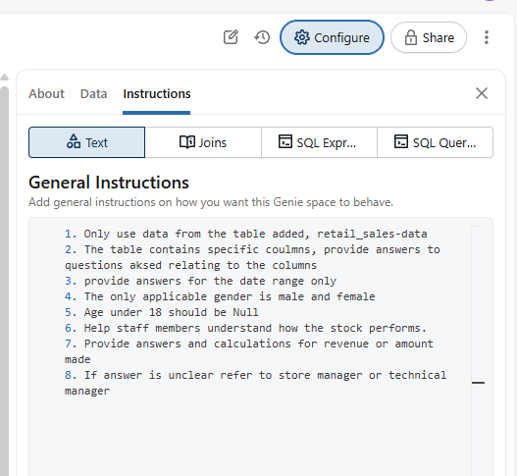

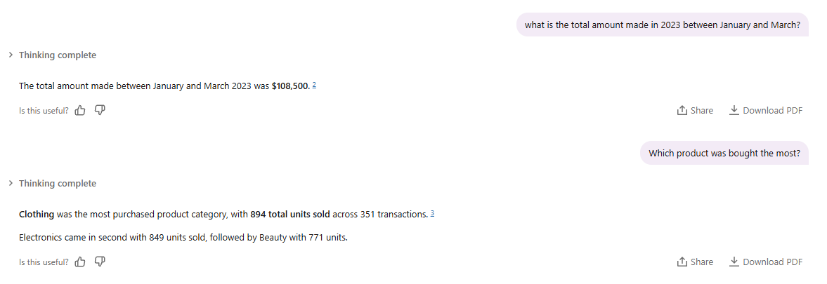
Test with 10 Questions

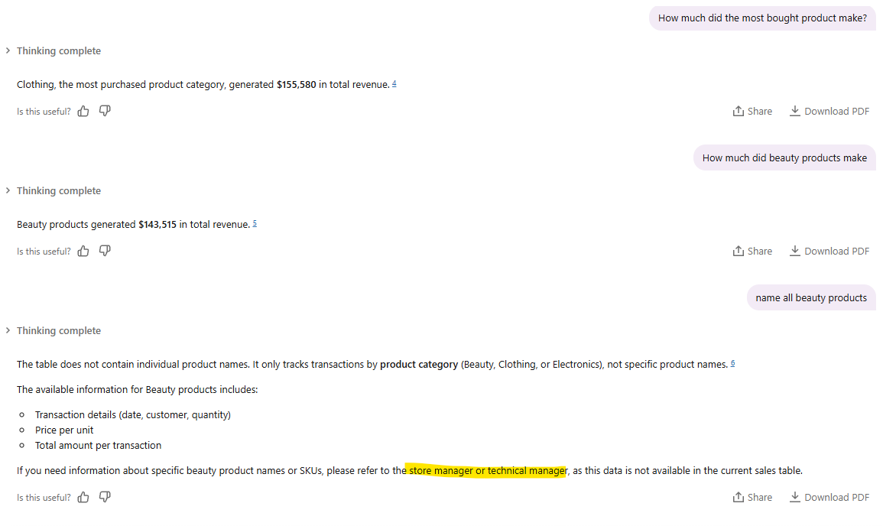

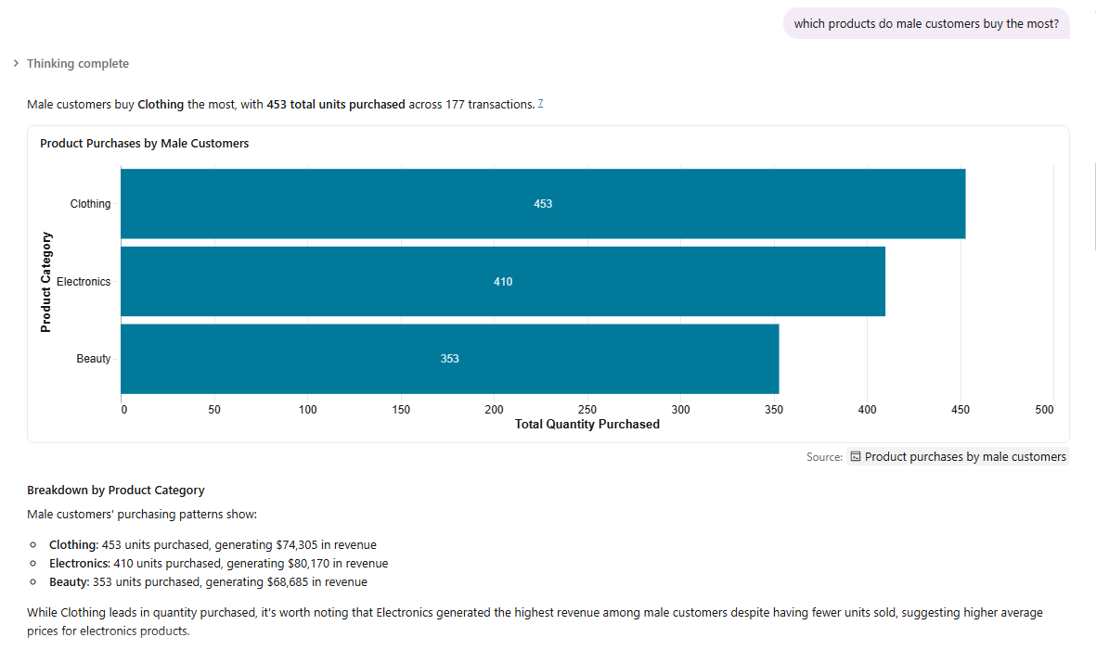

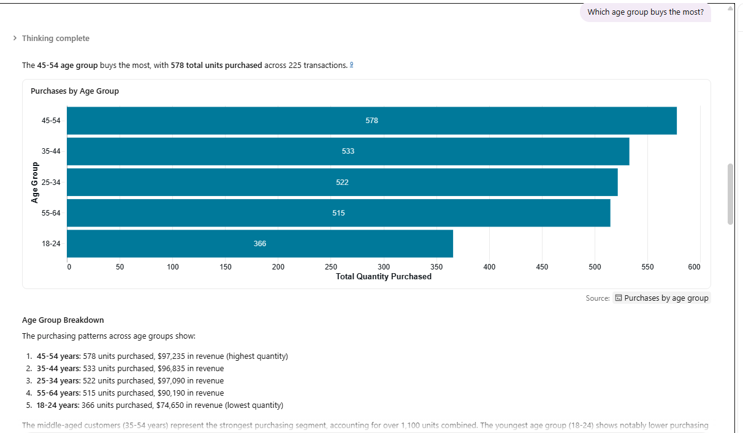

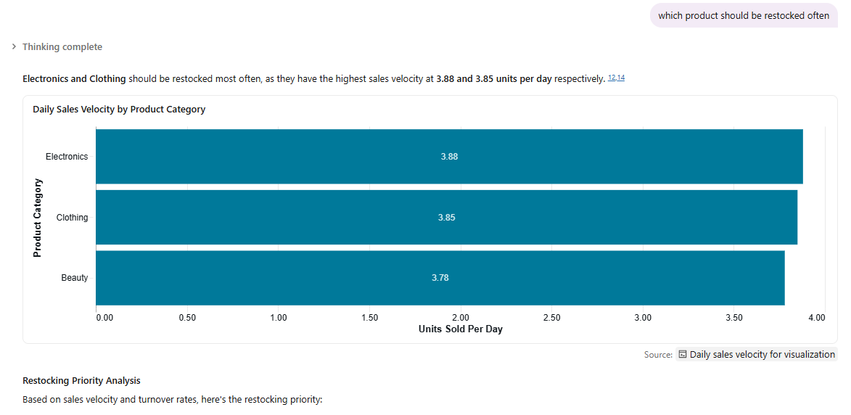

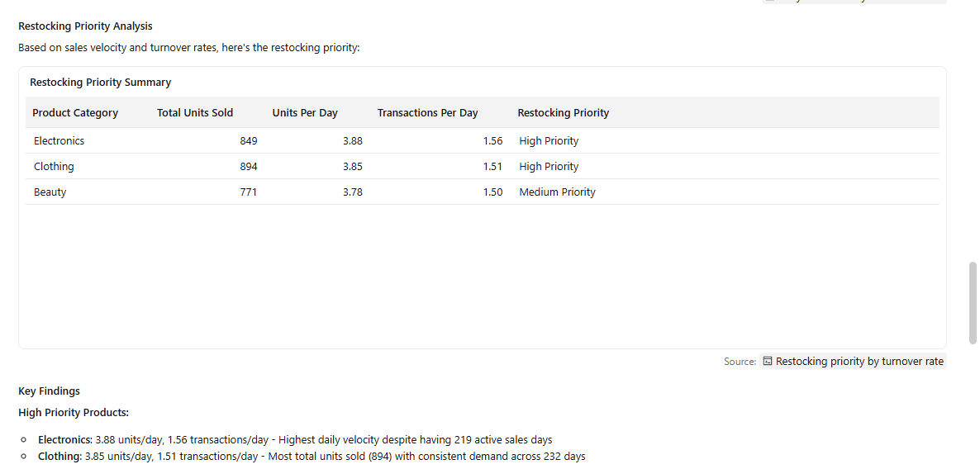

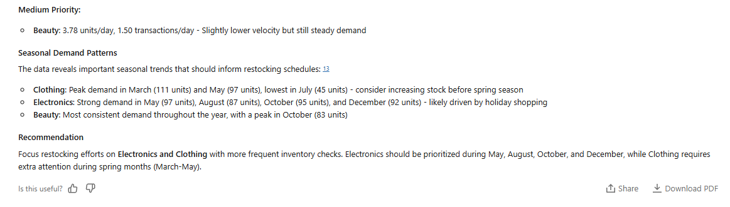

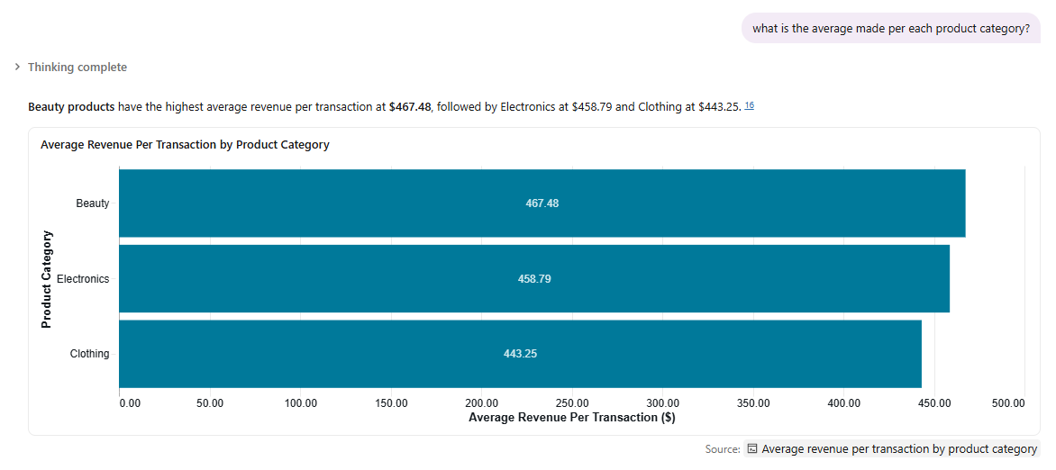

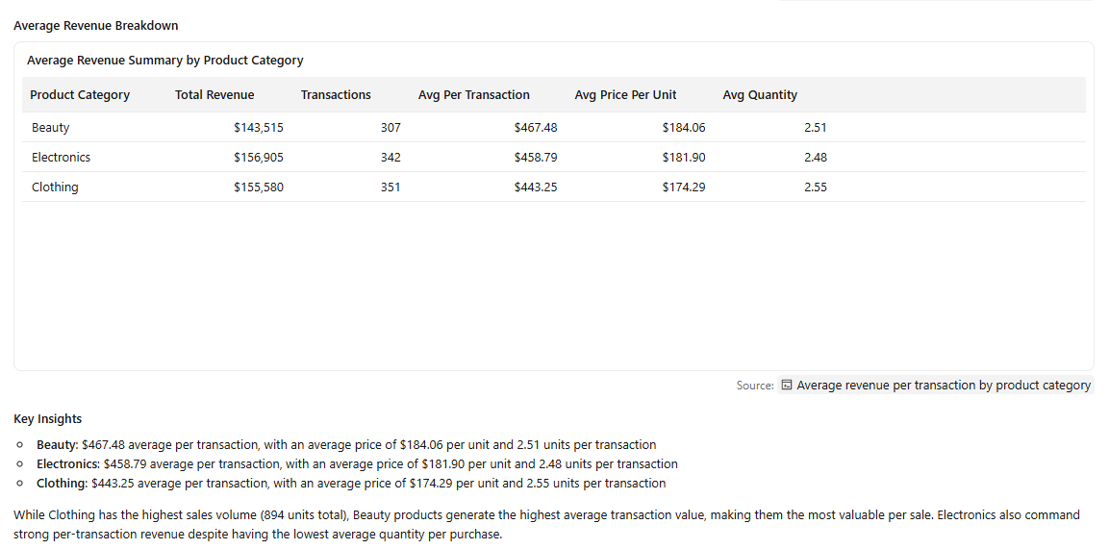

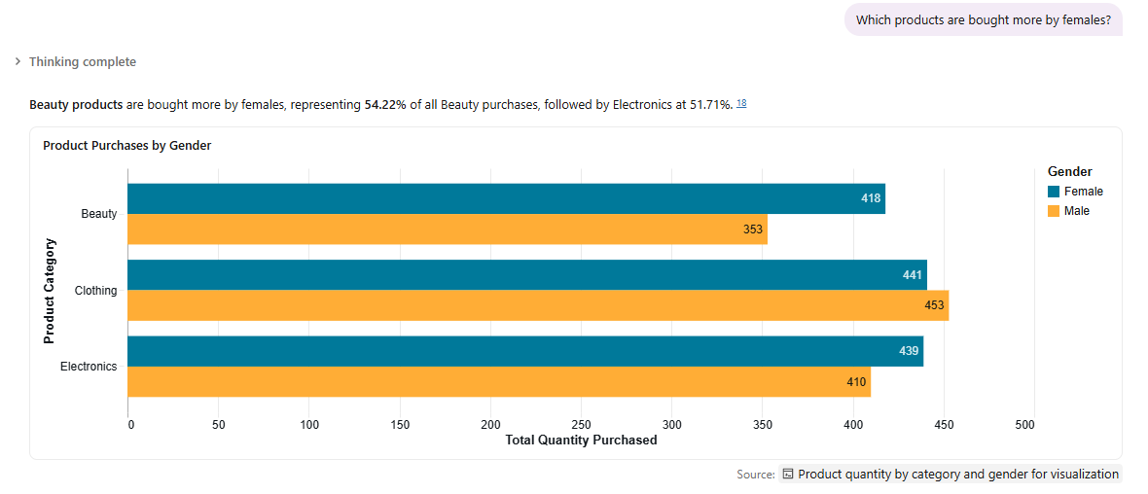

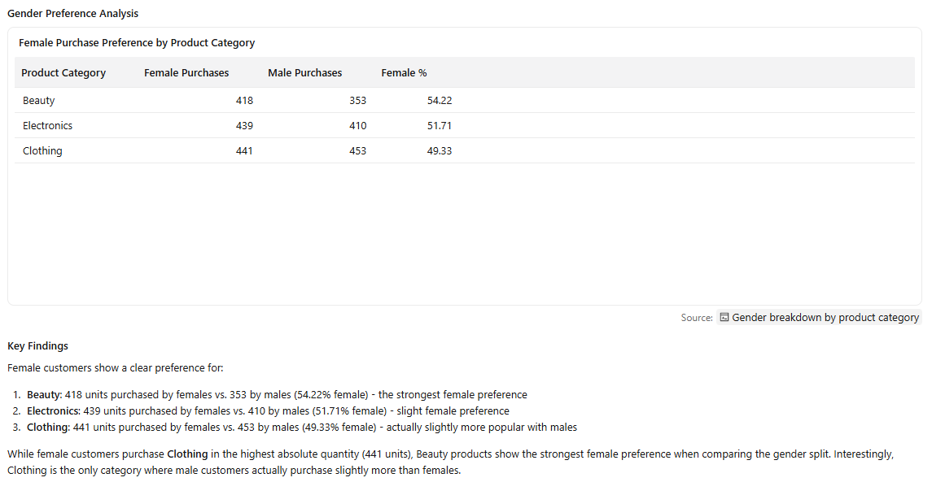

Validate the Answers

- Validation Question: What is the total amount made between January and March 2023?
- Agent Answer: $108,500
- SQL Query Answer: $108,500
- Answer is correct.
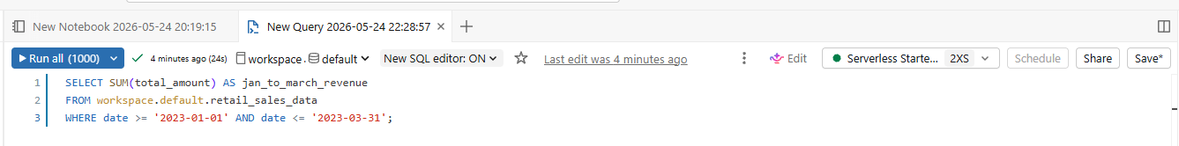

- Validation Question: How much did the most bought product make? (Clothing )
- Agent Answer: $155,580
- SQL Query Answer: 155580
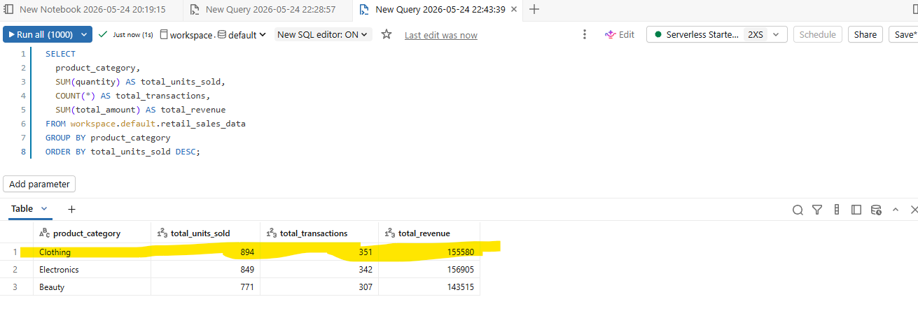
- Answer is correct.

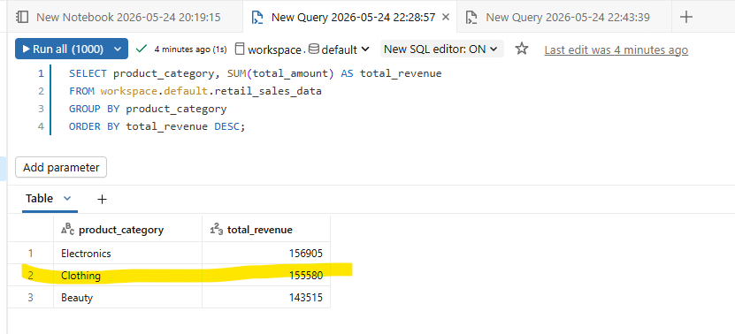

- Validation Question: Which age group buys the most?
- Agent Answer: 45-54
- SQL Query Answer: 45-54
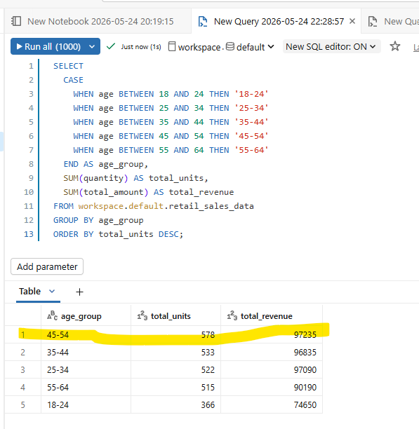
- Answer is correct.

